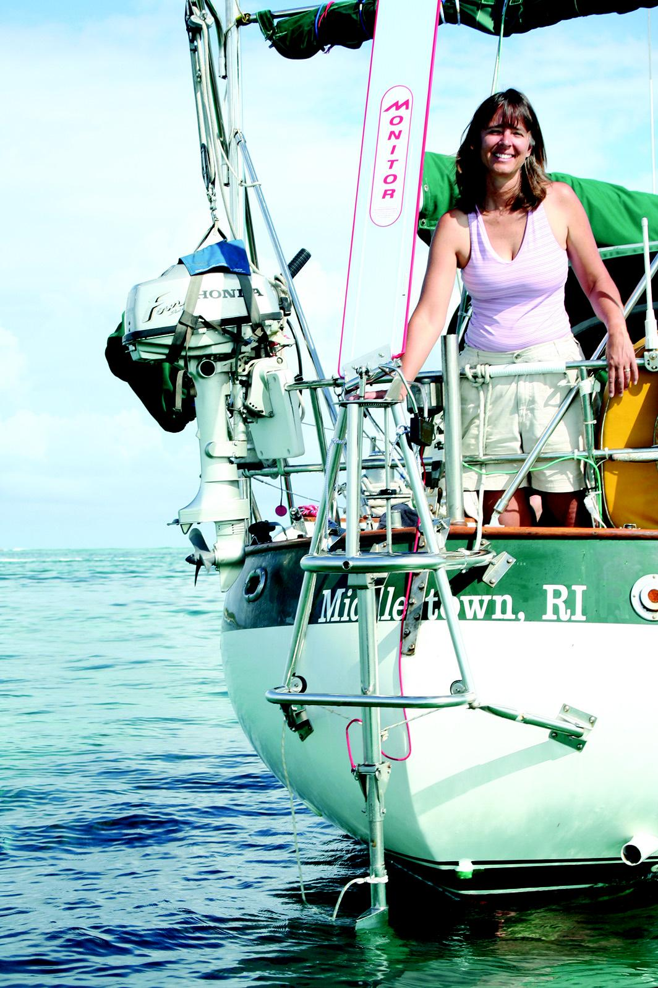
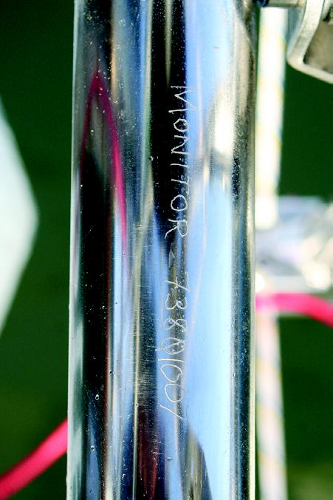
BRICK HOUSE: SELF-StEERING

Choosing
and using a
wind vane

Already installed on our boat,
Brick House, a 1976 Valiant 40, was
a Monitor self-steering vane. The
old Monitor had seen better days.
The linkages were worn and sloppy,
a lower strut was bent from a colli-
sion and the unit had no luster left
in the stainless steel. It was obvious
this Monitor had served previous
owners well but it would not steer
our Valiant 40 anymore.
I contacted Scanmar Interna-
tional. They knew the history of
this machine as they keep

72
Wor king with t he

mall boats with lone crews
tric autopilot or self-steering vane.
have been crossing oceans We do not use our strong, reliable,
for hundreds of years. autopilot while sailing since it
Self-steering was cer- consumes valuable amperage from
tainly in their minds but our battery bank and does not fol-
ingenious thinking escaped those low wind shifts for best boat speed.
early sailors, so they sailed on with a When sailing, even on simple day
lashing or their hand on the tiller. sails, our requirements called for a
On Brick House, we hardly ever dependable, trouble-free, self-steer-
steer our boat, on short or long pas- ing vane with a proven track record
sages. That work is left to the elec- of steering boats around the world.
records on all their self-
steering vanes. If there
are questions about a par-
ticular Monitor all one
needs is the serial num-
ber that is etched into
the unit. Sometimes an

Blue Water Sailing • March 2008

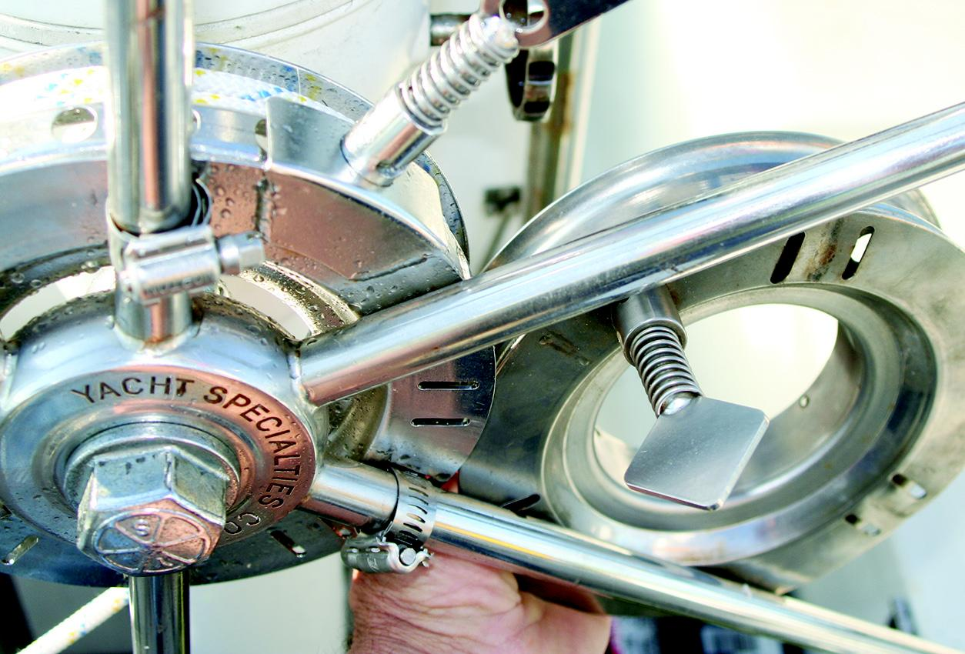
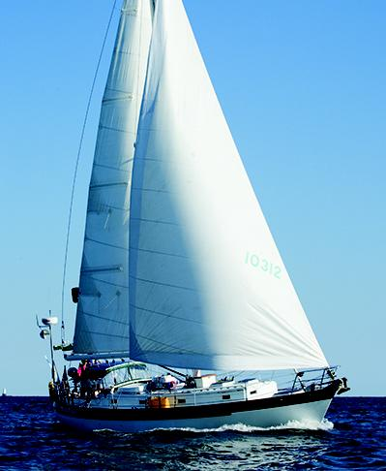

owners name or boat name can be
used as search criteria.
Our Monitor was built 24 years
ago and went through three boat
owners before I bought into Brick
House. Preparing our Valiant for
a circumnavigation, I ordered parts
from Scanmar to rebuild our Monitor.
As a delivery captain, I have
used Monitors on customers’ boats
and they always worked flawlessly.
Unfortunately this particular vane
did poorly even after I installed new
bearings, bush-
ings and linkages.
The old machine
still needed more
parts to get it
working properly.
It was time, like
an old car with
far too many
miles on it, to let
it go and invest in
a new machine.
All the self-steer-
ing vane options
were open to us.
It seems most of
the self-steering
vanes on the mar-

a drum on the steering wheel and
made the wheel and rudder turn.
That brought the sailboat back on
course. If the boat wandered off
course in the other direction, the
airvane leaned to the other side and
the series of events again went into
action bringing the boat back on
course.
This system is called a servo-
pendulum. In short, a servo-mech-
anism is a device in which the end
result generates a great force with

to produce a variety of
servo-pendulum wind vane
systems. Today the servo-pendulum
is the most common principle of
today’s commercially available wind
vanes.
Sailomat is a servo-pendulum
system that is easily bolted to a
transom. It does not have to be
mounted dead center on the tran-
som to work properly. Although in
heavy weather, off center mounting
can make a pendulum come near
the water’s surface,
affecting its per-
formance. Still, off
center mounting can
be a huge benefit to
some stern arrange-
ments. Since Sailomat
has been steering
boats for decades, it
has been refined and
upgraded to be a well
respected machine.
An interesting
version of the servo-
pendulum is the
lightly built Navik,
which was designed
for smaller boats up

ket today have
benefited from
years of success.
The old steering drum, above right, and the new. Monitor etches the
serial number into every unit, opposite left, for easy record keeping
to 30 feet. The Navik
had a very small
airvane with a linkage
that moved a trim tab

THE DEVELOPMENT OF
WIND VANES
Decades ago when I first saw
a self-steering vane steer a boat, I
stood near the stern and watched,
entranced by the ingenious move-
ment. It was the most amazing
thing. As the airvane was blown to
the side by a change in wind direc-
tion, that moved a linkage which
ultimately twisted the long arm of
a paddle in the water causing that
paddle to swing off to the side as
the boat moved forward through
the water. That sideways move-
ment of the paddle pulled a line
which, through pulleys, went to

Blue Water Sailing • www.bwsailing.com
only a small power input. A couple
of ounces push on the air vane
can translate into a 30-pound side
force on the water paddle. In strong
winds when the boat is sailing fast,
the lines attached to the pendulum
can yield several hundred pounds of
pull on the wheel or tiller.
The first servo-pendulum self-
steering vane was built by Blondie
Hassler to steer his junk rigged
folkboat Jester in the first transat-
lantic race in the early 1960s. That
original design was an impressive
clockwork of gears and levers. Over
the years other sailors modified
and simplified Hassler’s concept
on the back of the water paddle to
twist the water paddle causing the
paddle to swing off to the side as
the boat moved forward through
the water. Lines attached to the
paddle caused the tiller to move.
The trim tab operated like a small
aileron moving a large aircraft wing.
It was a powerful and efficient
system. Being lightly constructed,
the French-built Navik had many
drawbacks when put to the 24/7
test. A Navik steered my Catalina
27 around the world. After only
1,500 miles, plastic bushings and
linkages wore out and welds began
to fail; I was continually putting the

73

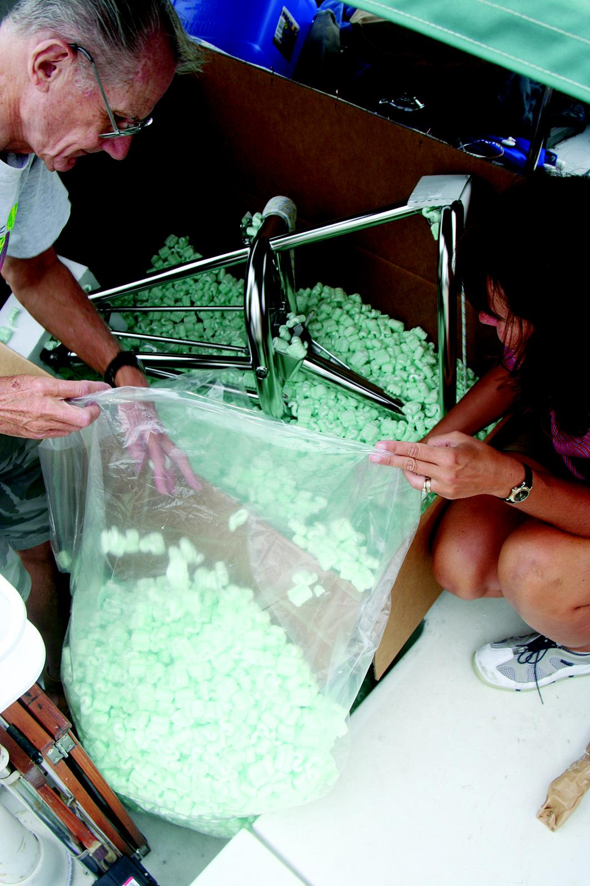
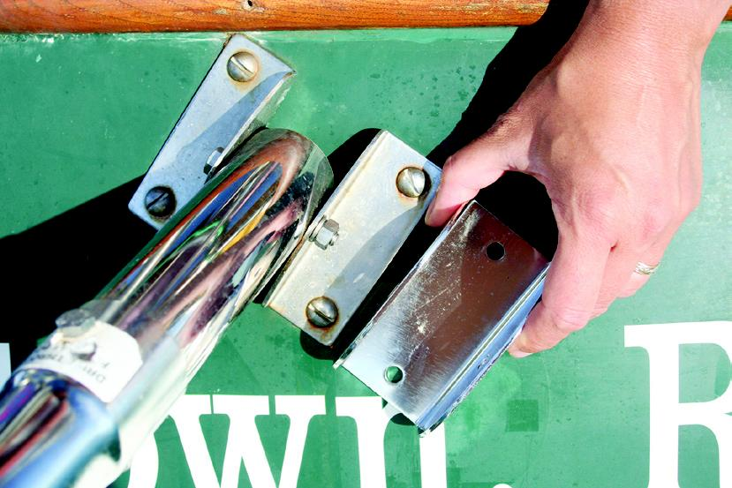
BRICK HOUSE: SELF-StEERING

from the boat or lifted out
of the water. Because of
this, the rudder must be
treated with antifouling
paint and creates drag even
when motoring. Turbu-
lence from prop wash and
backing down can also be
an issue with an auxiliary
rudder system.
The Hydrovane aux-
iliary rudder system is
different. The steering
rudder can be dismounted
by removing a single pin.
With the auxiliary rud-
der system the cockpit is
kept clear since there are

equipment. Racers equipped with
the Monitor supplied valuable feed-
back, which Scanmar incorporated
into newer models of the Monitor.
Today’s Monitor looks similar
to, but incorporates over 40 design
upgrades from the Monitors first
built in the 1970s. Improvements
over the decades have made the
Monitor one of the most successful
and reliable vanes available.
For Brick House, I chose to order
a new Monitor wind vane. I was
very familiar with the Monitor vane
and felt they had solid strength
in attachments and an impressive
track record and would be the most
suitable self-steering vane for our

The new Monitor is made of 316L stainless.
U-brackets, below, replace the L-brackets

Navik back together again.
no lines running around
the transom to the tiller or
steering wheel. The Hy-
drovane is a strong, well
tested, easily mounted
self-steering vane.
Cape Horn Integrated
Self-Steering, is a servo-
pendulum system. It was
designed to mount in
a two-and-a-half-inch
diameter hole drilled
through the transom of
a sailboat. Through this
hole, steering linkages are
routed to the boat’s steer-
voyage.
Since we had already sailed away
from our home in Rhode Island,
Scanmar quickly delivered the new
vane to friends in North Carolina.
When we opened the large box, the
first thing to fall out was not the
annoying foam packing “peanuts,”
but a large, heavy plastic bag to put
all the peanuts in. Already I was
impressed with Scanmar’s attention
to detail.
Our old Monitor was made of
304 stainless. I did not fully realize
how weathered that old machine
was till the new vane made of pol-

74
It seemed once Hassler made self-
steering a reality, experimentation
went in every direction. Another
variation of the self-steering idea
was the auxiliary rudder. Auxiliary
rudder systems rely on a secondary,
independent rudder mounted on
the stern of the boat. The auxiliary
rudder steers the boat once the boat
is set up for sailing and the boat’s
primary rudder is locked. One
authority feels that with an auxiliary
rudder aft of the main rudder his
boat turned in a much larger radius
and could have been more respon-
sive if the main rudder was doing
the steering. The auxiliary rudder
of some designs cannot be removed
ing quadrant. An alternate mount-
ing system is available so steering
lines can run to the cockpit and
attach to the wheel or tiller.

OUR NEW MONITOR
Scanmar International manufac-
tures the Monitor self-steering vane,
which is a servo- pendulum sys-
tem. Even 30 years ago the Moni-
tor was an unquestionable racer’s
choice for around the world races
like the BOC and Around Alone.
Sailing through some of the worst
boat pounding latitudes of the
world, these racers often surfed in
huge seas at speeds up to 18 knots
throwing decades of abuse at their
ished 316L stainless steel emerged
from the box. This was a grown-up’s
Christmas present.
Removing the tarnished Monitor
from the stern of Brick House was
a simple matter of removing four
bolts where the mounting tubes
attach to L brackets. L brackets are
no longer used with new Moni-
tors. They have been replaced with
U-shaped brackets, which require
half the number of mounting bolts
into the hull of the boat. Since the
mounting tube diameter has not
changed, I chose to not take the
time to plug and patch existing
holes in our stern only to drill new
holes. We used the old brackets to

Blue Water Sailing • March 2008

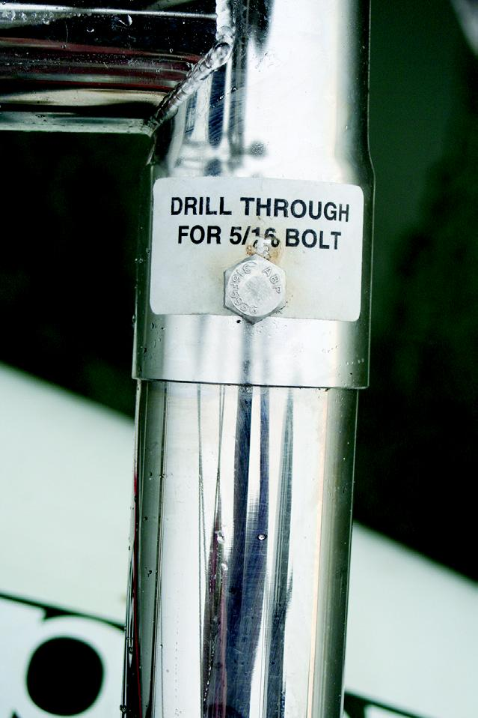

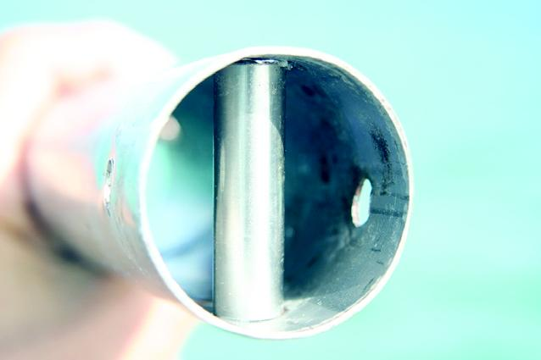

Sparks will fly when you cut the stainless steel tubes. Small compression
tubes, bottom right, give extra rigidity to the support leg

mount our new vane.
A friend and I set the two new
upper mounting tubes into the
brackets on the stern and marked
where to drill our first set of hori-
zontal bolt holes. Drilling holes into
stainless steel tubing is not difficult
if you use sharp cobalt or titanium
bits. Also, the drill must be rotating

sion spacer tubes to line up with
the drill holes. The little spacer
pipe gives additional rigidity to the
bolted area of the support leg.
After the upper support tubes
were in place I was able to tempo-
rarily secure the Monitor with a
line to the stern rail. With a bubble
level we made sure the fore and aft

slowly while applying great pressure
on the bit. Drilling at high rpm and
soft pressure heats the metal thereby
hardening the metal and making
it more difficult to drill. With the
two short mounting tubes bolted in
place, we were able to slip the vane
frame onto the tubes. It took a little
oil on the metal tubes and a bit of
persuasion with a rubber mallet
but the parts finally slipped solidly
together. It was obvious where
the next two bolt holes would be
drilled. Scanmar already drilled
pilot holes and attached idiot-proof
labels where the two vertical five-
eighths-inch bolt holes were to be
drilled in the upper supports.
Once the bolt holes were drilled,
we removed the frame from the
support tubes so we could force
into the support legs the compres-

Blue Water Sailing • www.bwsailing.com
direction of the Monitor was level.
Then we installed the lower sup-
port legs. The original installation
on Brick House did not position the
lower support brackets in the best
position. I was going to live with
that error, which meant we had to
shorten the new lower legs. If I had
used the new U-shaped brackets no
cutting would have been necessary
and the exact mounting angles, as
instructed by Monitor, would have
been followed.
Stainless steel tubes can be cut
with a hacksaw, reciprocating saw
or a four-and-one-half-inch angle
grinder with a steel cutting disk,
which is what I prefer. The tool
fits easily in our tool locker on the
boat and is used for a lot of boat
projects when metal has to be cut.
To keep the cut straight, you first
make a guide by circling the tube
with masking tape. As if you were
using a pipe cutter, score around
the tube several times till the scores
finally make their way through the
tube. Cutting aggressively straight
through the tube creates too much
heat, sparks and jagged edges.
The lower support legs also get
compression tubes slipped inside
before inserting the mounting
bolts. With the lower support legs
bolted in place the next step was
the simple matter of attaching the
hinge and water paddle assembly
by securing it with a stainless steel
hinge pin. Now the pendulum sheet
lines could be run to the steering
drum on the wheel.
The fewer blocks the sheets run
through on the way to the steering
drum the less friction there will be.

75


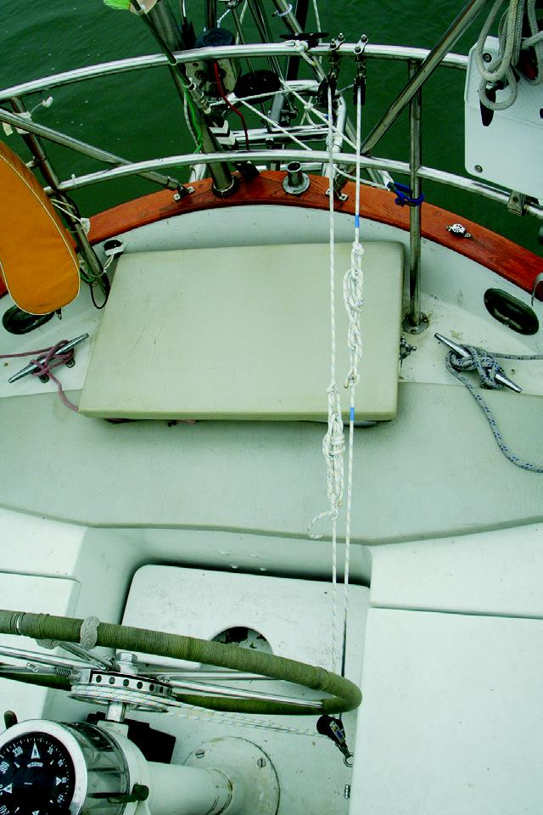
BRICK HOUSE: SELF-StEERING

The Monitor Special Knot, far left, is
used to attach the pendulum sheets
to the lines coming off the steering
drum, left. The new wind vane
does not seem to be affected by a
cluttered transom, opposite

in the opposite direction you want
the boat to turn.
The old Monitor air vanes were
made of plywood and worked well.
The new air vanes are made of a
reinforced hollow polycarbonate
plastic, which are strong, lighter
and, being less affected by humidi-
ty, hold their shape better. There are
two sizes of air vanes supplied. The
tall vane we use in most weather
conditions.
Even though our stern is crowd-
ed with outboard engines, anchors,
life rings and stuff, the tall vane

76
Blocks with long shackles can in-
duce absorption of line movement
resulting in a cushioned response
so fixed blocks are preferred. Our
installation just would not allow
fixed blocks, so we made sure the
shackles holding the blocks in place
were as short as possible.
A “Monitor Special Knot” is
used to attach the pendulum sheets
to the lines coming off the steer-
ing drum. This knot allows for the
proper tensioning of the sheets to
the drum. The sheets need to be
snug enough to take out the slack
but not overly tight to induce fric-
tion. At anchor, the knot is easily
untied to clear the cockpit of these
lines. On our set up, I have marked
the port pendulum sheets with blue
tape so when preparing for a sail,
joining the proper lines together
again does not become a puzzle. If
the pendulum sheets ever have to be
replaced, I will use different colors
for the port and starboard sheets.

SEA TRIALS
The swap out of the old Monitor
with a new machine took a friend
and me eight hours to complete.
From that experience I would think
a new installation would take two
people a full weekend.
For new installations on most
popular boats, Monitor has all the
knowledge to send the Monitor
ready to bolt onto the transom.
Along with the new Monitor comes
an installation manual, which is
very methodical and full of detailed
illustrations (it is also available
in PDF format on the company’s
website www.selfsteer.com). The
installation package also includes
elevation plans with all the dimen-
sions needed to precisely mount
the Monitor. There are a lot of little
steps but the manual takes the mys-
tery out of the installation.
Under sail, engaging the Moni-
tor to steer the boat takes only a
few moments. You just pick out the
compass course and hand steer it as
closely as possible. The most impor-
tant thing is to set and balance the
sails. An over-trimmed sail pulling
a boat into the wind is difficult
enough for a helmsman to over-
come and even more so for a steer-
ing vane. Once the boat is trimmed
and sailing nicely, rotate the airvane
so the leading edge is pointed into
the wind and standing vertically.
Below, the paddle will be slicing
vertically through the water. Twist
the pin lock into the nearest hole
on the wheel drum and let go of
the steering wheel. The self-steering
vane is now in control of the boat.
To change direction, simply rotate
the airvane the number of degrees
seems to not be bothered by this
potential wind interference. When
the weather pipes up to over 20
knots and the wind is on the beam
or forward, we reduce the sensitiv-
ity of the airvane by installing the
shorter vane.
At anchor or under way, the pen-
dulum easily unlocks to lift out of
the water or lower to the down and
locked position.
Recently we were sailing down-
wind, seven miles off the Atlantic
coast of Florida. Downwind sailing
is normally the biggest challenge
for a self-steering vane since there is
less relative wind over the air vane,
making it less responsive to course
changes. Brick House was being
pulled by a spinnaker, poled out jib
and a full main. We installed the
tall airvane. Along with the course-
disturbing roll of a three-foot
swell, the Monitor had no problem
keeping our Valiant 40 on course in
the 12-knot breeze. In lighter wind
conditions, I ease the tension on
the Monitor Special Knot so there
will be less friction over the blocks
making the sideways force of the
pendulum more efficient.
The Monitor proved equally as
reliable in stronger weather. We
left Miami, just ahead of fore-
casted 20-knot north winds, for the
45-mile crossing to Bimini, Baha-

Blue Water Sailing • March 2008


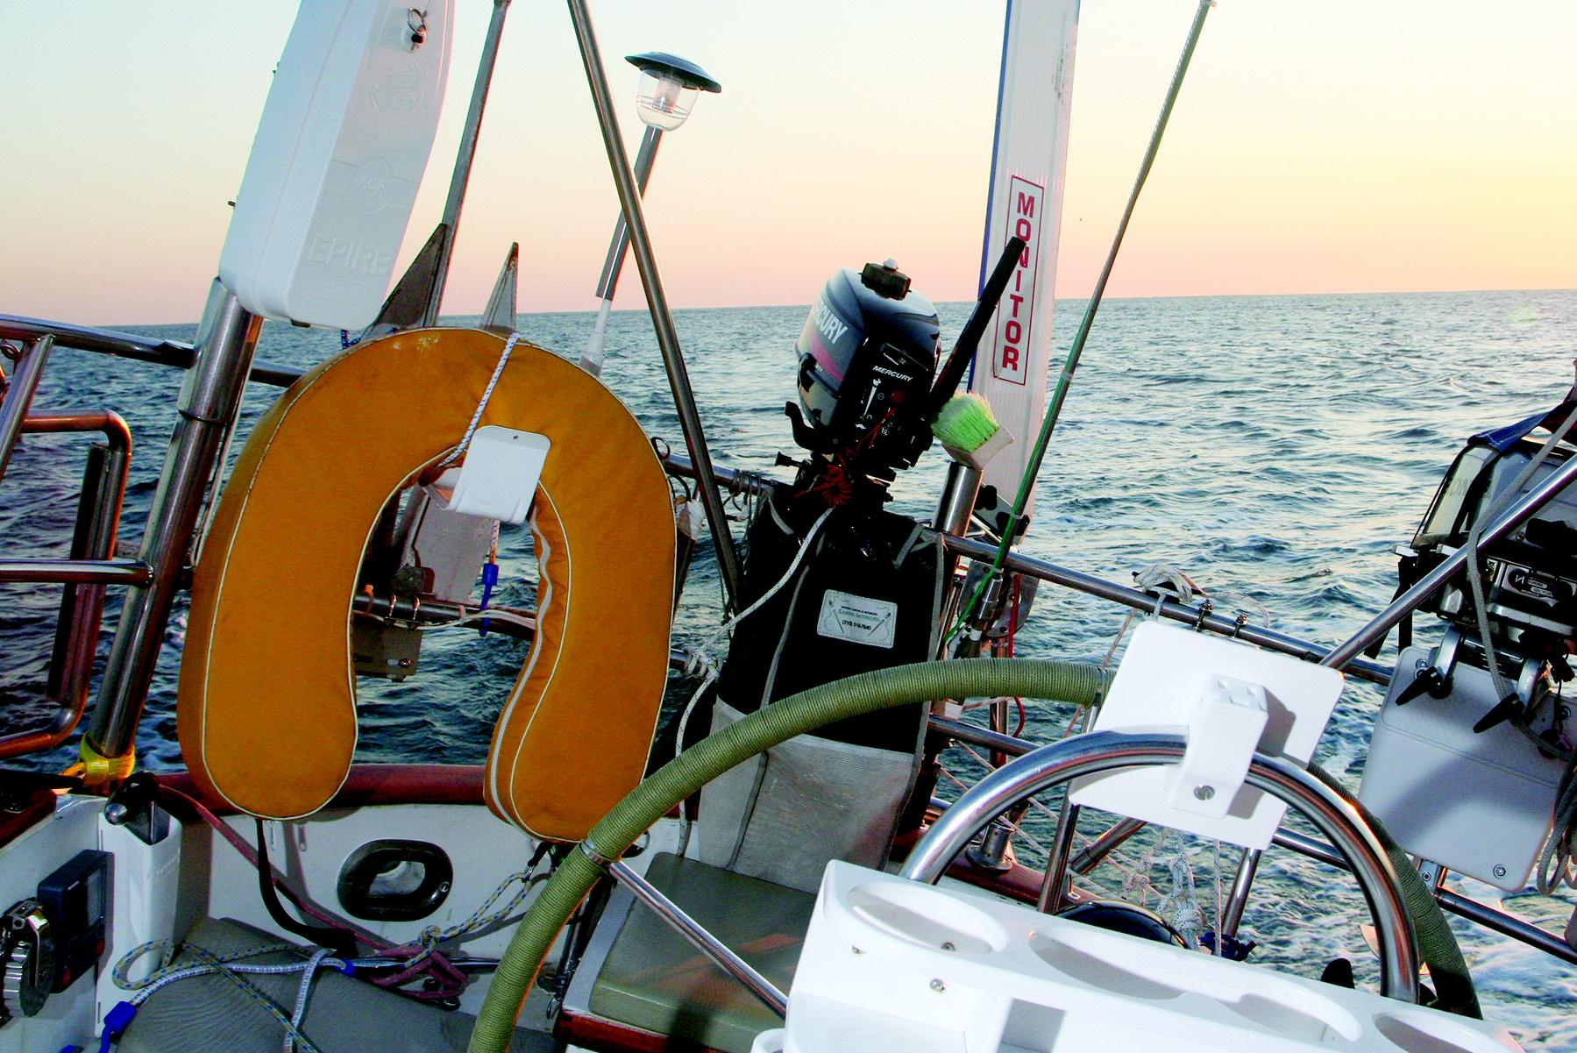

mas. The wind bucking the Gulf
Stream chopped up the waves to
eight feet. The Monitor is the only
one that caught spray as the crew
was ducked behind the dodger. We
had a fast and uneventful passage.

THE PERFECT CREW
A self-steering vane is a perfect
crew. It is brainless, operates tire-
lessly and forever will hold a course
relative to the wind but not a com-
pass course. In mid-ocean this is
not a problem. Closing on land or
threading your way through islands
like the Bahamas, a bad wind shift
gone unnoticed by the more cranial
on board could result in a keel-
crunching mess. This has happened
to a few yachts whose crew thought
they could catch one more catnap

before taking a look around or
before altering course.
The only maintenance we per-
form on our Monitor is to wash it
down, along with the rest of our
stainless steel, with fresh water any
chance we get. At sea, the delrin
bearings are water lubricated. The
roller and ball bearings are loosely
set in stainless steel races. This
allows splashing seawater to wash
out unwanted accumulations unless
the skipper has oiled or greased
the bearings. Oil and grease will
mix with the salts and gum up the
works.
On a short handed cruising
yacht, the self-steering vane is an
absolutely necessary tool. The last
thing I need is for my hand to be
on the wheel when an ingenious

modern day invention that
needs no sleep or food or electricity,
can do a far better job in just about
any condition.
Aries
www.ariesvane.com
www.selfsteer.dk
Cape Horn
www.capehorn.com
Fleming
www.flemingselfsteer.com
Hydrovane
www.hydrovane.com
Monitor
www.selfsteer.com
Sailomat
www.sailomat.com
Voyager
www.voyagerwindvanes.com
Wind Pilot
www.windpilot.com

Blue Water Sailing • www.bwsailing.com

77

